Workout split generator and recommendation- App

## CS19611 – Mobile Application Development Laboratory

***Submitted by***

**MAGIZHAN SIVAKUMAR 220701154**

***in partial fulfillment for the award of the degree of***

**BACHELOR OF ENGINEERING**

***in***

# COMPUTER SCIENCE AND ENGINEERING



**RAJALAKSHMI ENGINEERING COLLEGE ANNA UNIVERSITY, CHENNAI**

# MAY 2025

RAJALAKSHMI ENGINEERING COLLEGE, CHENNAI

**BONAFIDE CERTIFICATE**

Certified that this Project titled **“Workout split generator and recommendation- App”** is the bonafide work of **“ MAGIZHAN SIVAKUMAR 220701154”** who carried out the work under my supervision. Certified further that to the best of my knowledge the work reported herein does not form part of any other thesis or dissertation on the basis of which a degree or award was conferred on an earlier occasion on this or any other candidate.

|  |  |
| --- | --- |
| Dr. P.Kumar  **HEAD OF THE DEPARTMENT**  Professor and Head Department of  Computer Science and Engineering Rajalakshmi Engineering College Rajalakshmi Nagar  Thandalam  Chennai - 602105 | Mr.Karthik.V  **SUPERVISOR**  Assistant Professor (SG) Department of  Computer Science and Engineering  Rajalakshmi Engineering College Rajalakshmi Nagar  Thandalam |

Chennai - 602105 Submitted to Project Viva-Voce Examination held on

**Internal Examiner External Examiner**

# ABSTRACT

**"Workout Split Generator and Recommendation – App"** is an Android-based mobile application developed using **Kotlin** and **Jetpack Compose**, aimed at fitness enthusiasts seeking personalized and structured workout plans. This application addresses a common challenge faced by gym-goers and fitness beginners: creating balanced and effective workout splits that align with their goals, schedule, and fitness levels. By integrating a smart split generator with real-time recommendations, the app acts as a virtual fitness planner tailored to individual user needs.

The core functionality of the application revolves around generating workout splits—weekly routines that divide training into targeted muscle groups or exercise types (e.g., push/pull/legs, upper/lower body, full-body circuits). Users input basic information such as fitness goals (muscle gain, fat loss, endurance), experience level (beginner, intermediate, advanced), available workout days, and preferred training style. Based on this input, the app generates a personalized weekly plan. It also provides recommendations for exercises, sets, reps, and rest intervals, aligning with the chosen goal and user preferences.

Built using **Jetpack Compose**, the app features a modern, intuitive, and responsive user interface. Compose’s declarative UI approach allows for dynamic screen rendering, real-time updates, and smooth navigation between screens without the need for XML-based layouts. Components like ViewModel and State ensure efficient management of UI data and enhance user experience by reflecting changes instantly.

The recommendation engine uses pre-defined logic and customizable templates to offer workout guidance. In future iterations, the logic can be enhanced using machine learning or rule-based systems to provide even more personalized recommendations. Additionally, users can modify or save their generated splits for future reference.

# ACKNOWLEDGMENT

Initially we thank the Almighty for being with us through every walk of our life and showering his blessings through the endeavor to put forth this report. Our sincere thanks to our Chairman **Mr. S. MEGANATHAN, B.E, F.I.E.**, our Vice Chairman **Mr. ABHAY SHANKAR**

**MEGANATHAN, B.E., M.S.,** and our respected Chairperson **Dr. (Mrs.) THANGAM MEGANATHAN**, **Ph.D.,** for

providing us with the requisite infrastructure and sincere endeavoring in educating us in their premier institution.

Our sincere thanks to **Dr. S.N. MURUGESAN, M.E., Ph.D.,** our beloved

Principal for his kind support and facilities provided to complete our work in time. We express our sincere thanks to **Dr. P. KUMAR, M.E., Ph.D.**, Professor and Head of the Department of Computer Science and Engineering for his guidance and encouragement throughout the project work. We convey our sincere and deepest gratitude to our Project Coordinator**, Mr. N. DURAI MURUGAN, M.Tech., Ph.D.,** Professor Department of Computer Science and Engineering for his useful tips during our review to build our project and for his valuable guidance throughout the course of the project.

**MAGIZHAN SIVAKUMAR 220701154**

|  |  |  |
| --- | --- | --- |
|  | **TABLE OF CONTENTS** |  |
| **CHAPTER NO.** | **TITLE PAGE NO.** |
|  | **ABSTRACT** **iii**  **ACKNOWLEDGMENT** **iv** |
|  | **LIST OF TABLES** **vii** |
|  | **LIST OF FIGURES** **viii** |
|  | **LIST OF ABBREVIATIONS ix 1. INTRODUCTION 11** |
|  | 1.1 GENERAL 11 |
|  | 1.2 OBJECTIVES 11 |
|  | 1.3 EXISTING SYSTEM 12 |
| **2.** | **LITERATURE SURVEY** **13** |
| **3.** | **PROPOSED SYSTEM 16** |
|  | 3.1 GENERAL 16 3.2 SYSTEM ARCHITECTURE DIAGRAM | 17 |
|  | 3.3 DEVELOPMENT ENVIRONMENT 19 |  |
|  | 3.3.1 HARDWARE REQUIREMENTS 19 |  |
|  | 3.3.2 SOFTWARE REQUIREMENTS 19 |  |
|  | 3.4 DESIGN THE ENTIRE SYSTEM 20 |  |
|  | 3.4.1 ACTIVITY DIAGRAM 20 |  |
|  | 3.4.2 DATA FLOW DIAGRAM 21 |  |
|  | 3.5 STATISTICAL ANALYSIS 23 |  |
| **4.** | **MODULE DESCRIPTION** **25** |  |

* 1. SYSTEM ARCHITECTURE 25
     1. USER INTERFACE DESIGN 25
     2. BACK END INFRASTRUCTURE 26
  2. SYSTEM WORKFLOW 28
     1. USER INTERACTION 28
     2. ICD CODE PREDICTION 28
     3. RESULT DISPLAY & REPORTING 28
     4. CONTINUOUS MODEL IMPROVEMENT 28

1. IMPLEMENTATIONS AND RESULTS 29
   1. IMPLEMENTATION 29
   2. OUTPUT SCREENSHOTS 29
2. CONCLUSION AND FUTURE ENHANCEMENT 34
   1. CONCLUSION 34
   2. FUTURE ENHANCEMENT 34

REFERENCES 36

**LIST OF TABLES** **5**

* 1. HARDWARE REQUIREMENTS 18
  2. SOFTWARE REQUIREMENTS 18

|  |  |  |  |  |  |
| --- | --- | --- | --- | --- | --- |
| **TABLE NO** | | **TITLE** | | | **PAGE NO** |
| 3.3 | | COMPARISON OF FEATURES | | | 23 |
| **LIST OF FIGURES** | |  | | |  |
| **FIGURE NO**  3.1 | **TITLE**  SYSTEM ARCHITECTURE | | | **PAGE NO**  18 | |
| 3.2 ACTIVITY DIAGRAM | | | 20 |  | |
| 3.3 DFD DIAGRAM | | |  | 22 | |
| 4.1 SEQUENCE DIAGRAM | | |  | 25 | |

* 1. DATASET FOR TRAINING 31
  2. PREDICTION RESULT 33

**LIST OF ABBREVIATIONS**

**ABBR Expansion UI** – User Interface

**UX** – User Experience

**API** – Application Programming Interface

**DB** – Database

**SDK** – Software Development Kit

**HTTP** – Hypertext Transfer Protocol

# 1.1GENERAL

**CHAPTER 1 INTRODUCTION**

In today’s fast-paced world, maintaining a healthy lifestyle and consistent workout routine is a challenge for many individuals. While numerous fitness apps exist, they often overwhelm users with complex features or lack personalized workout plans. To bridge this gap, **“Workout Split Generator and Recommendation – App”** is designed as a smart, easy-to-use Android application that helps users create tailored workout splits based on their fitness goals, experience level, and available time.

# 1.2 OBJECTIVE

The primary objective of this project is to design and develop an Android application that assists users in generating personalized workout splits and exercise recommendations based on their individual fitness goals, availability, and experience levels. This app aims to simplify fitness planning for beginners and intermediate users by automating routine structuring and offering guidance without the need for a personal trainer.

# 1.2EXISTING SYSTEM

In the current landscape of fitness and health applications, numerous mobile apps exist that aim to help users manage their workouts, track progress, and maintain motivation. Popular applications such as **Nike Training Club**, **FitOn**, **JEFIT**, and **MyFitnessPal** offer features like guided workouts, exercise databases, and progress tracking. However, despite their popularity, many of these applications have limitations when it comes to **personalized workout split generation** and real-time, tailored exercise recommendations based on user-specific inputs.

# CHAPTER 2 LITERATURE SURVEY

In recent years, the integration of mobile technology with health and fitness has seen significant growth, leading to the development of a wide range of fitness applications. These apps aim to assist users in tracking workouts, maintaining exercise routines, and achieving their health goals. This literature survey explores existing research papers, mobile applications, and technologies that have influenced the design and development of intelligent fitness planning systems.

## Fitness Apps and User Engagement

Several studies have shown that mobile fitness apps can positively influence user behavior and promote consistency in physical activity. According to a 2020 research study titled *“Mobile Health Apps and User Motivation”* (International Journal of mHealth and uHealth), apps that offer **customization, clear goal setting, and interactive interfaces** lead to higher levels of user engagement. However, the same study found that most users abandoned fitness apps that lacked **personalization and adaptability** to their daily schedules.

## Workout Planning and Split Routines

Workout splits, which divide exercise sessions by muscle groups or training styles (e.g., push/pull/legs, full-body, or upper/lower splits), are widely used in resistance training. Research published in the *Journal of Strength and Conditioning Research* (2018) highlights the effectiveness of **split-based training** in improving muscle hypertrophy and strength when tailored to an individual's capacity and recovery time. Despite their effectiveness, most existing mobile apps do not automate split generation or adapt it dynamically based on user input.

## Existing Mobile Applications

**JEFIT** and **StrongLifts 5x5**: Offer structured strength training programs, but are rigid in design and lack flexible split creation.

**Nike Training Club** and **FitOn**: Provide guided video workouts with some customization, but do not focus on personalized split planning.

**MyFitnessPal**: Integrates diet and exercise logging but does not offer workout plan generation. These applications demonstrate the capabilities of fitness apps but also highlight the absence of **personalized split recommendations** and smart scheduling features based on user availability and goals.

## Jetpack Compose and Modern Android Development

Jetpack Compose, introduced by Google as a modern toolkit for building native Android UIs, has enabled developers to create more dynamic and reactive interfaces. According to Google I/O 2021, Compose enhances development speed, UI consistency, and responsiveness— especially for apps requiring frequent updates and interactivity. It is ideal for fitness applications where the UI must adapt to changing user states and data inputs.

## Use of Recommendation Systems

Basic rule-based recommendation engines are commonly used in domains like e-commerce and media, and are now being adopted in fitness technology. A study titled *“A Recommendation System for Physical Training Using User Behavior and Preferences”* (IEEE, 2019) demonstrated how even simple logic-based systems could improve user adherence to fitness plans by offering **context-aware suggestions**.

**CHAPTER 3**

**PROPOSED SYSTEM**

**3.1 GENERAL**

The proposed system aims to provide personalized and efficient workout plans for fitness enthusiasts, helping users achieve their fitness goals (muscle gain, fat loss, endurance) by generating customized workout splits and providing real-time recommendations for exercises, sets, reps, and rest intervals. The system will be built using **Kotlin** and **Jetpack Compose**, ensuring modern, intuitive, and responsive UI/UX.

## 3.2. System Architecture

The system architecture will be based on the following components:

## User Interface (UI):

**Jetpack Compose** for dynamic and responsive screen rendering.

Views for input (fitness goals, experience level, available days, etc.) and displaying workout splits and recommendations.

Real-time updates and smooth navigation between screens.

## Business Logic:

**Workout Split Generator**: A module that generates weekly workout routines based on user input (fitness goals, experience level, and preferred training style).

**Recommendation Engine**: Provides suggestions for exercises, sets, reps, and rest intervals based on the user's chosen split and goals.

**User Profile Management**: Stores user information like goals, experience level, and preferences, along with workout history and progress.

## 3.Data Layer:

**Exercise Database**: A collection of exercises categorized by muscle group, equipment needed, and difficulty level.

**Workout Templates**: Predefined templates for common workout styles (e.g., push/pull/legs, upper/lower body, full-body) to serve as the basis for generating splits.

**User Data Storage**: Local storage (Room Database or similar) to save user profiles, workout splits, exercise logs, and progress.

## API Layer :

**Integration with Wearables**: If integrated, APIs will be used to sync data from wearables (e.g., heart rate, steps, calorie expenditure).

**External Nutrition Database** (optional): A connection to a nutrition database to provide users with dietary suggestions based on their goals.

## Recommendation System:

A rule-based engine that can suggest workouts and exercises based on user preferences and goals. This can later be enhanced with **machine learning** algorithms to provide more personalized recommendations based on user feedback, progress, and patterns.

## Key Features and Functionalities Personalized Workout Splits:

**User Input**: Users enter details such as:

Fitness goal (muscle gain, fat loss, endurance) Experience level (beginner, intermediate, advanced) Number of available workout days per week

Preferred training style (push/pull/legs, upper/lower body, full-body, etc.)

**Dynamic Split Generation**: Based on the user’s input, the system generates a weekly workout routine (e.g., 4-day push/pull/legs split or 3-day full-body routine).

**Exercise Recommendations**: For each workout day, the system recommends specific exercises, sets, reps, and rest intervals that align with the user’s goals.

## Real-Time Recommendations:

The app suggests exercises that can be performed based on user inputs (e.g., available equipment or preferred exercises).

Each exercise is accompanied by detailed instructions, including proper form, sets, reps, and rest intervals.

**Exercise Variations**: The app recommends exercise variations for muscle engagement and to prevent workout monotony.

## Progress Tracking:

Users can log their performance for each workout (weights lifted, reps completed, etc.). **Visual Progress**: Track progress via graphs showing improvement in various metrics (strength, endurance, etc.).

The system can adjust future workout splits based on progress or lack thereof.

## Workout Customization:

Users can modify the generated splits, save their custom plans, and create templates for future reference.

Option to adjust exercises, sets, reps, or rest intervals based on preferences.

## User Profiles and History:

Each user has a profile containing their fitness goals, workout history, preferences, and progress. Users can revisit old splits, track changes in their workout regimen, and assess improvements over time.

## Notifications and Reminders:

Push notifications to remind users of upcoming workouts or recovery days. Motivation and encouragement messages tailored to user progress.

## Wearable Integration (Optional):

Sync data from fitness trackers (e.g., heart rate, calories burned) to adjust workout intensity or give insights into recovery status.

## Optional Nutrition Guidance:

Suggest calorie and macronutrient recommendations based on the user’s fitness goals (muscle gain, fat loss).

Basic meal suggestions that complement the workout routines.

## User Flow

**Onboarding Process**:

First-time users are prompted to input their basic information (fitness goal, experience level, available days, etc.).

Users are introduced to the app with a quick tutorial on how to navigate and utilize the key features.

## Home Screen:

Displays the user’s generated workout split for the current week. Option to modify the split or generate a new one.

Overview of the user’s progress and upcoming workouts.

## Workout Day Screen:

Displays the exercises for that day, with sets, reps, and rest intervals. Users can log their performance and track progress in real-time.

## Profile Screen:

Displays detailed user information, workout history, and progress reports. Option to update goals, preferences, and adjust workout frequency.

## Settings:

Option to integrate with wearables, manage notifications, or change language/region settings.

## Technology Stack Frontend (UI):

Kotlin, Jetpack Compose for building dynamic, responsive interfaces. Navigation Component for easy navigation between screens.

LiveData and ViewModel for managing UI data and ensuring efficient updates.

## Backend :

Firebase or REST API for user authentication and syncing data across devices (if required). Room Database for local storage of user data, progress logs, and workout splits.

## Recommendation Engine:

Initially rule-based, with plans to incorporate **machine learning** for adaptive workout suggestions.

## Future Enhancements

**Machine Learning Integration**: The recommendation engine could evolve to incorporate machine learning algorithms that suggest workout adjustments based on user feedback and performance history.

**Social Features**: Enable users to share workout splits, progress, and achievements with friends or a broader fitness community.

**Advanced Analytics**: Provide in-depth analytics on workout performance, calorie burn, and muscle growth based on exercise history.

**Integration with Other Fitness Apps**: Sync data from popular fitness apps like MyFitnessPal, Strava, or Google Fit for a comprehensive view of user health and progress.

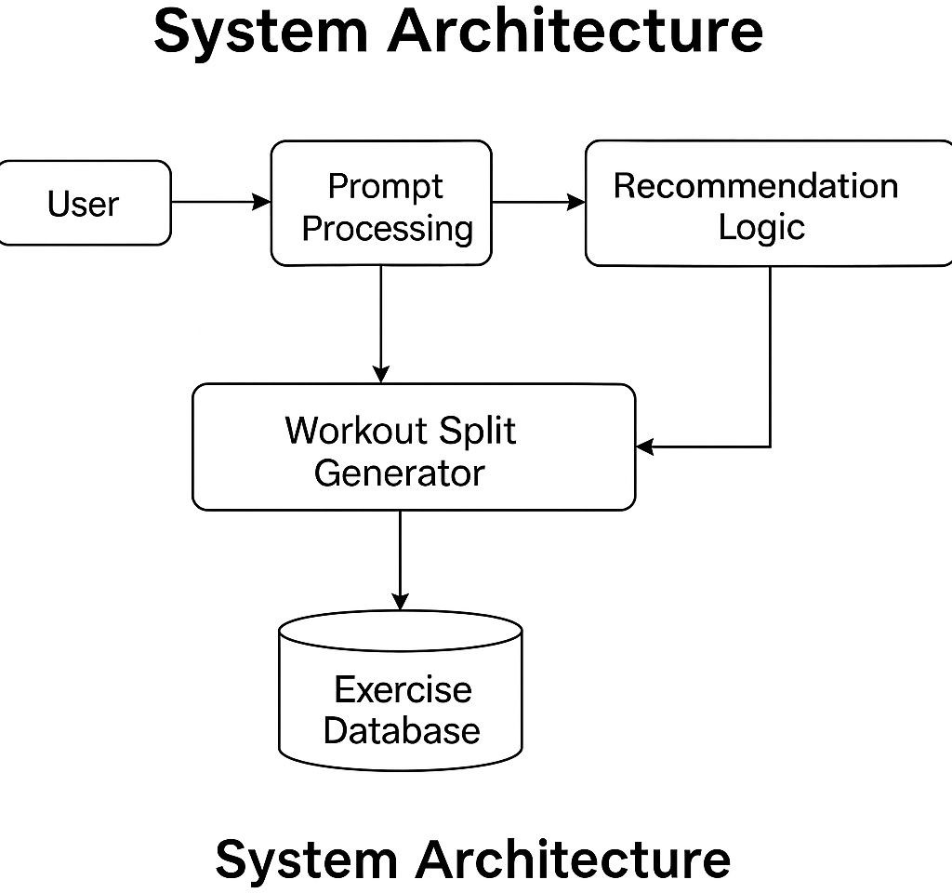

**Fig 3.1: System Architecture**

# DEVELOPMENTAL ENVIRONMENT

* + 1. **HARDWARE REQUIREMENTS**

These specifications represent the lowest requirements for the app to function properly without significant performance issues. Devices meeting these specifications will be able to run the app, but performance might not be optimal.

## Processor (CPU):

**Type**: ARM-based processor (e.g., ARMv7 or higher).

**Speed**: 1.0 GHz or higher.

**Cores**: At least 2 cores for decent performance.

## RAM (Memory):

**Size**: 2 GB of RAM (or higher).

This will ensure the app can handle moderate processing tasks, such as workout split generation, data logging, and UI rendering.

## Storage:

**Internal Storage**: 16 GB (or higher).

Sufficient space to store user data, workout logs, and app updates. It is important to leave enough storage for other applications and system operations.

## Display:

**Screen Size**: 4.5 inches (minimum).

**Resolution**: 480x800 pixels (WVGA) minimum.

This ensures readability of text and proper UI scaling for smaller screens.

## Operating System:

**Android Version**: Android 6.0 (Marshmallow) or higher.

The app will require modern Android APIs to function properly, and certain Jetpack Compose features may not be supported on older versions of Android.

## Battery:

**Capacity**: At least 2000mAh.

A decent battery will ensure that the app can be used for extended workout sessions without draining too quickly.

**Table 3.1 Hardware Requirements**

|  |  |
| --- | --- |
| **COMPONENTS** | **SPECIFICATION** |
| PROCESSOR | Intel i5 or above (recommended) |
| RAM | 8 GB RAM OR Higher |
| HARD DISK | Minimum 4 GB free space |
| DISPLAY | 1280 x 720 resolution or higher |
| SMARTPHONE | Android 7.0 (API 24) and above |

# SOFTWARE REQUIREMENTS

The software requirements will include the **development tools**, **frameworks**, **libraries**, and **third-party services** required to build, deploy, and maintain the app. Below is a breakdown of the software needed for both the development process and the operation of the app once deployed.

## Development Tools

* 1. **IDE (Integrated Development Environment)**

Android Studio:

Android Studio is the official IDE for Android development. It supports Kotlin (the primary language for the app) and integrates seamlessly with Jetpack Compose for UI design.

Features like Emulator, Code Linting, Debugging, and Real-time Preview will ensure efficient development and testing.

## Programming Languages

* 1. **Kotlin**

**Kotlin** is the primary programming language for Android development and will be used to implement the app’s logic, functionality, and UI. Kotlin offers modern features, null safety, and full interoperability with Java, making it ideal for Android apps.

## XML (For Compatibility with Views)

While the app will primarily use **Jetpack Compose** for UI, certain compatibility or legacy features might require XML for layouts (for backward compatibility with older Android devices or components).

**Table 3.2 Software Requirements**

# SOFTWARE COMPONENTS DESCRIPTION

|  |  |
| --- | --- |
| Operating System | Windows 10 / macOS / Linux |
| IDE | Android Studio (Electric Eel / later) |
| Programming Language | Kotlin (with Jetpack Compose) |
| Design Tool | XML for UI (Jetpack Compose UI Toolkit) |

**SOFTWARE COMPONENTS DESCRIPTION**

Emulator / Device Android Emulator or physical Android phone

Database (Optional) Firebase (can be added in future)

# DESIGN OF THE ENTIRE SYSTEM

* + 1. **ACTIVITY DIAGRAM**

The activity diagram illustrates the sequential flow of operations in the “Workout Split Generator and Recommendation – App,” showcasing how users interact with the system from start to finish. The process begins when the user launches the app, initiating the workflow. The user is first

prompted to register or log in, depending on whether they are new or returning. Upon successful authentication, the user is guided to input essential details such as fitness goals (e.g., muscle gain, fat loss, endurance), experience level (beginner, intermediate, advanced), available workout days, and preferred training style (e.g., push/pull/legs, upper/lower body). These inputs are then processed by the app’s built-in logic to generate a personalized workout split tailored to the user's objectives and availability. The system then displays the proposed workout plan. If the user is not satisfied, they have the option to return and modify their preferences, allowing for customization and refinement. Once the user approves the plan, they can view a detailed daily workout schedule, which includes exercises, sets, reps, and rest intervals. The user proceeds to perform their workouts while the app tracks completion and progress, which can later be saved locally or optionally synced to cloud storage or wearable devices for better analytics. This activity concludes once the workout session is completed, after which the user can repeat the cycle or adjust their plans as needed.

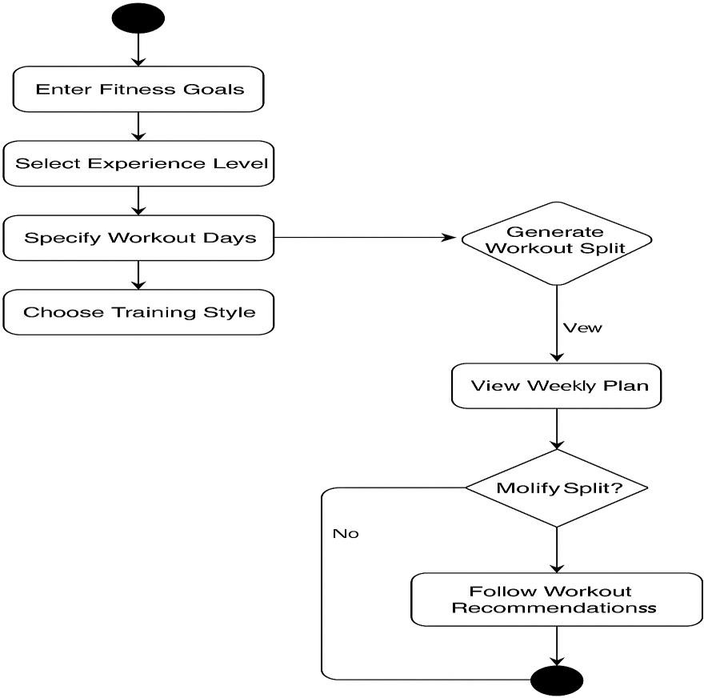

# DATA FLOW DIAGRAM

The Data Flow Diagram (DFD) of the “Workout Split Generator and Recommendation – App” visually represents how data moves through the system, outlining key processes, data stores, and interactions with external entities. At the context level (Level 0), the system is depicted as a single process interacting with the user, who inputs personal preferences such as fitness goals, experience level, and workout availability. This data flows into the system, which processes it to generate a personalized workout plan using internal logic and a predefined exercise database. The output—workout splits and daily exercise routines—is then sent back to the user. The system may also interface with external services like cloud storage (e.g., Firebase) for user data synchronization and with fitness APIs or wearables for enhanced exercise tracking.

In the more detailed Level 1 DFD, the system is broken down into several subprocesses: user authentication, preference input, workout plan generation, plan display, and progress tracking. Data stores like the user profile, exercise templates, generated workout plans, and user progress logs are used to retain and retrieve information during these operations. For instance, when a user logs in, the authentication module checks credentials against the user profile data store.

# STATISTICAL ANALYSIS

Statistical analysis in the context of **Packify** focuses on understanding user behavior, app usage patterns, and the effectiveness of the packing process. By collecting data on how frequently users add, update, or delete items from their packing lists, we can derive insights into which features are most utilized and where users may encounter difficulties. For instance, statistical analysis can help identify common packing items across different travel types, such as business trips or leisure vacations. Additionally, tracking completion rates of packing lists and user feedback on suggested items can indicate whether the recommendations provided by the app are truly useful. The data collected can be used to improve the app’s features, enhance item suggestions, and optimize the overall user experience.

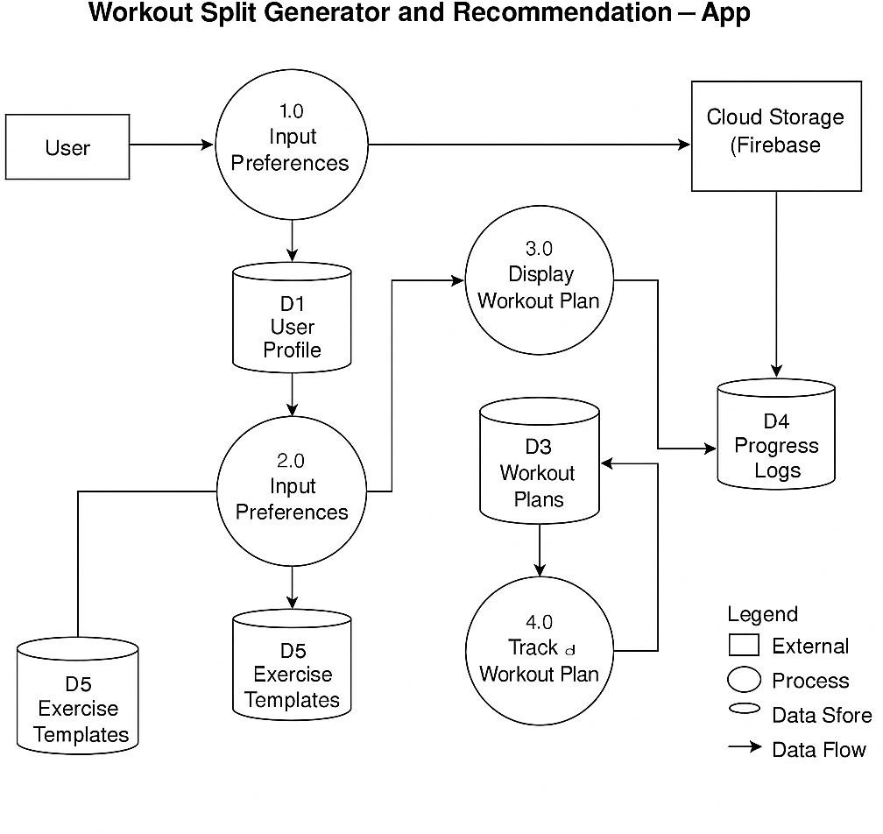

**Fig 3.3:Data Flow Diagram**

# CHAPTER 4

**MODULE DESCRIPTION**

The “Workout Split Generator and Recommendation – App” is divided into several interconnected modules that work together to deliver a seamless and personalized fitness planning experience. The User Authentication Module handles user registration and login, ensuring secure access and personalized tracking. Once authenticated, users are directed to the User Input Module, where they provide essential details such as fitness goals (e.g., muscle gain, fat loss, endurance), experience level, available workout days, and preferred training style. This data is processed by the Workout Split Generation Module, which uses rule-based logic and predefined templates to generate a weekly workout plan tailored to the user’s profile.

# SYSTEM ARCHITECTURE

The system architecture of the “Workout Split Generator and Recommendation – App” follows a modular, layered approach that separates concerns across user interaction, business logic, and data management layers to ensure maintainability, scalability, and performance. At the front end, the Presentation Layer is developed using Jetpack Compose, which handles the dynamic user interface and user interactions. This layer communicates with the ViewModel Layer, which acts as a bridge between the UI and the underlying business logic. The ViewModel holds UI state, processes user inputs, and invokes core functions like workout generation and data validation. The Business Logic Layer contains the core recommendation engine, which processes user-provided inputs (such as fitness goals, experience level, and workout preferences) to generate customized workout splits using predefined templates and rule-based logic.

# USER INTERFACE DESIGN

The User Interface (UI) of the “Workout Split Generator and Recommendation – App” is designed with a focus on simplicity, responsiveness, and personalization to enhance user engagement and accessibility. Built using **Jetpack Compose**, Android’s modern declarative UI toolkit, the app features a clean and intuitive design that dynamically adapts to user interactions and screen sizes. The interface is structured into multiple screens, including the login/register screen, user input form, workout split overview, daily exercise breakdown, and progress tracker. Each screen is designed with minimalistic elements, smooth transitions, and consistent color schemes to ensure a cohesive user experience. Interactive components such as dropdowns, radio buttons, sliders, and confirmation dialogs guide users effortlessly through the process of entering preferences and reviewing their workout plans. Real-time updates powered by Compose’s state management ensure that changes to user inputs immediately reflect in the UI without reloads. Additionally, accessibility considerations such as large touch targets, readable fonts, and contrast-rich layouts have been integrated to support usability across diverse user groups. Overall, the UI design not only provides an engaging visual experience but also enhances the functional reliability of the app by making it easy to navigate, customize, and track fitness routines.

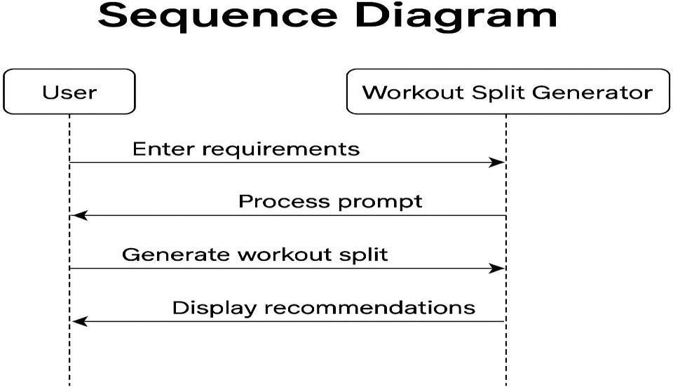

**Fig 4.1: SEQUENCE DIAGRAM**

# BACK END INFRASTRUCTURE

The back-end infrastructure of the “Workout Split Generator and Recommendation – App” is designed to support reliable data processing, user data management, and cloud-based functionality while ensuring performance and scalability. Although the application is primarily client-side for initial versions, it leverages **Firebase** as a cloud backend to handle essential services such as **user authentication, real-time database management, and cloud storage**. Firebase Authentication provides secure login and registration functionality, allowing users to create accounts and store their fitness data securely. The **Firebase Realtime Database** or **Cloud Firestore** is used to store structured user data such as workout preferences, generated plans, and progress logs, allowing for seamless data retrieval and synchronization across sessions and devices. For additional cloud features, **Firebase Cloud Storage** can manage larger files or image uploads if needed in future updates (e.g., progress photos). The back end also supports integration with third-party **fitness APIs or wearable SDKs**, enabling real-time fitness tracking and syncing data such as steps, heart rate, or calories burned. Communication between the front end and back end is secured using encrypted protocols (HTTPS), and Firebase’s rules engine ensures access control and data integrity. This infrastructure supports scalability, allowing the app to grow in functionality and user base with minimal architectural changes.

**CHAPTER 5**

**IMPLEMENTATION AND RESULTS**

# IMPLEMENTATION

The implementation of the “Workout Split Generator and Recommendation – App” was carried out using Kotlin as the programming language and Jetpack Compose for building the user interface. The development process began with designing core screens such as the login/registration interface, user input forms, workout split viewer, and daily exercise planner. Each screen was structured using Jetpack Compose’s declarative UI approach, allowing the app

to react to state changes in real time without needing traditional XML layouts. The logic behind workout plan generation was implemented using conditional structures and rule-based templates, which mapped user inputs (like fitness goals, experience level, and available workout days) to predefined exercise splits such as push/pull/legs or full-body routines.

User input data is handled by **ViewModels**, which maintain the UI state and coordinate between the interface and business logic. Data persistence is managed using **Room Database** or **Firebase Firestore**, depending on whether offline or cloud-based storage is selected. Firebase Authentication was integrated to manage user accounts securely, while progress tracking features allow users to save and review completed workouts. Modular implementation of each component ensured easier testing and future upgrades. The application was tested on various Android versions and screen sizes to ensure compatibility and responsiveness. Overall, the implementation emphasizes modularity, real-time UI responsiveness, and an intuitive workflow that aligns with fitness users' goals and habits.

# OUTPUT SCREENSHOTS

The output screenshots of the “Workout Split Generator and Recommendation – App” visually demonstrate the functionality and user interface flow of the application. The first screenshot showcases the Login and Registration screen, where users can securely sign in or create an account using Firebase Authentication. Once logged in, the next screenshot captures the User Input screen, allowing users to select their fitness goals, training experience, preferred workout split style, and the number of days available for training. The third screenshot displays the Generated Workout Plan, which presents a structured weekly split based on the user's preferences, clearly organized by training days and targeted muscle groups.

Another key screenshot highlights the Daily Workout Detail View, showing exercises, sets, reps, and rest intervals customized for that day. Additionally, there are output screens showing the Progress Tracking Interface, where users can mark completed exercises and track their

consistency over time. For cloud-integrated versions, screenshots of Firebase synced data and optional wearable integration may be included to show real-time health tracking. These screenshots collectively validate the application’s core functionality, aesthetic design, and usability across various modules of the app.

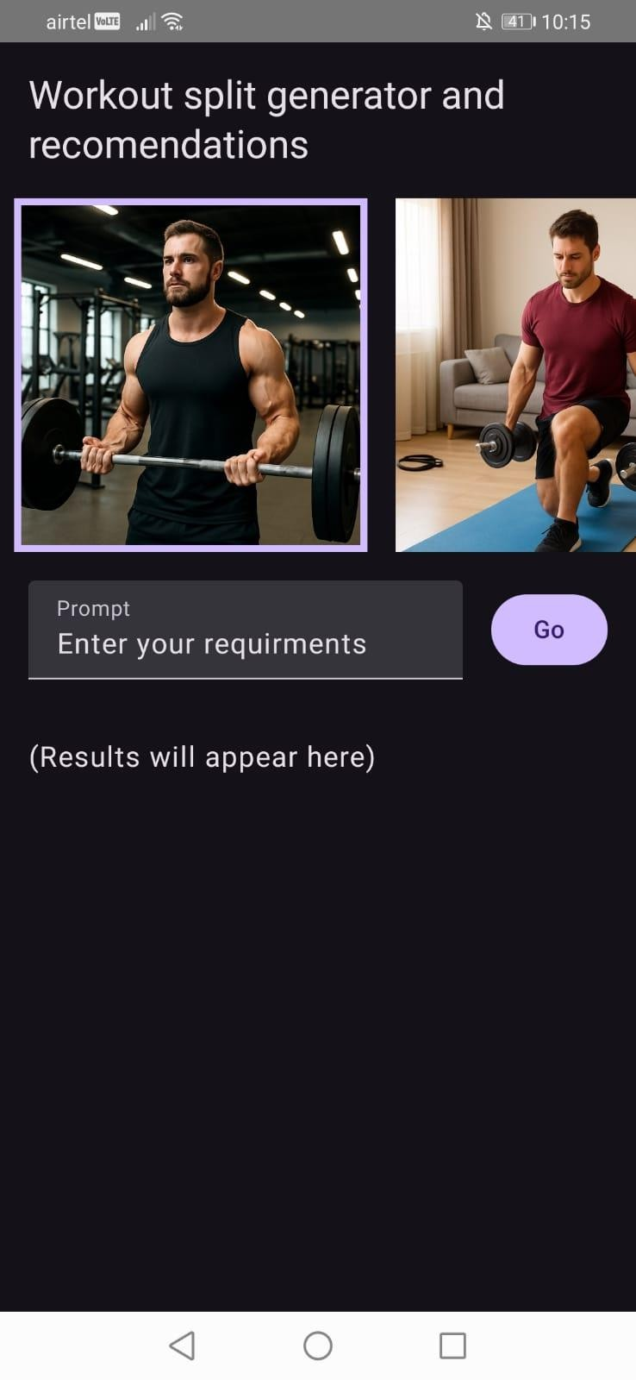

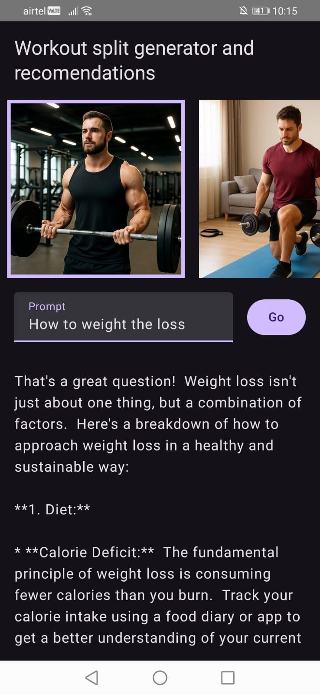

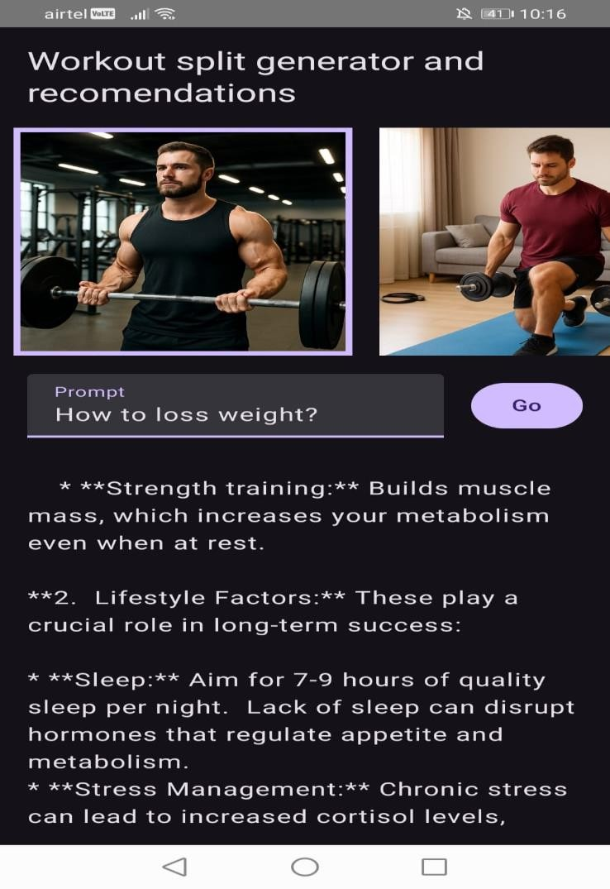

**CHAPTER 6**

**CONCLUSION AND FUTURE ENHANCEMENT**

# CONCLUSION

The “Workout Split Generator and Recommendation – App” successfully addresses the need for a personalized, structured, and accessible fitness planning tool for users of all experience levels. By allowing users to input their specific fitness goals, available workout days, and training preferences, the app dynamically generates effective workout splits tailored to their needs. Developed using Kotlin and Jetpack Compose, the app delivers a modern, responsive, and user-friendly interface, while leveraging Firebase services for secure authentication and cloud-based data storage. The modular architecture ensures smooth functionality, maintainability, and scalability for future enhancements, such as AI-based recommendations or integration with wearables. Through its smart logic, intuitive design, and customizable features, the app not only simplifies the workout planning process but also encourages consistency, progress tracking, and long-term fitness engagement. This project demonstrates how technology can empower users to take control of their health goals through intelligent automation and design.

* 1. **FUTURE ENHANCEMENT**

While the current version of the “Workout Split Generator and Recommendation – App” provides a strong foundation for personalized workout planning, there are several potential enhancements that can significantly improve functionality and user experience. One major improvement would be the integration of **AI or machine learning algorithms** to generate smarter, more adaptive workout plans based on user history, progress, and behavior patterns. Adding **wearable device integration** (e.g., Fitbit, Google Fit) would allow real-time tracking of metrics like heart rate, steps, and calories burned, which could be used to dynamically adjust training intensity. Another key enhancement would be introducing **in-app reminders, calendar syncing, and progress notifications** to boost user engagement and adherence. The app could

also support **community features** such as workout challenges, social sharing, or peer comparisons to foster motivation.

# SOURCE CODE

package com.example.workout

import org.junit.Test

import org.junit.Assert.*

/**

* Example local unit test, which will execute on the development machine (host).

*

* See [testing documentation]([http://d.android.com/tools/testing).](http://d.android.com/tools/testing))

*/

class ExampleUnitTest { @Test

fun addition_isCorrect() { assertEquals(4, 2 + 2)

}

}

COLOR.KT

package com.example.workout.ui.theme

import androidx.compose.ui.graphics.Color

val Purple80 = Color(0xFFD0BCFF)

val PurpleGrey80 = Color(0xFFCCC2DC) val Pink80 = Color(0xFFEFB8C8)

val Purple40 = Color(0xFF6650a4)

val PurpleGrey40 = Color(0xFF625b71) val Pink40 = Color(0xFF7D5260) Baking screen:

package com.example.workout

import android.graphics.BitmapFactory

import androidx.compose.foundation.BorderStroke import androidx.compose.foundation.Image import androidx.compose.foundation.border import androidx.compose.foundation.clickable

import androidx.compose.foundation.layout.Column import androidx.compose.foundation.layout.Row import androidx.compose.foundation.layout.fillMaxSize

import androidx.compose.foundation.layout.fillMaxWidth import androidx.compose.foundation.layout.padding import androidx.compose.foundation.layout.requiredSize import androidx.compose.foundation.lazy.LazyRow import androidx.compose.foundation.lazy.itemsIndexed import androidx.compose.foundation.rememberScrollState import androidx.compose.foundation.verticalScroll

import androidx.compose.material3.Button

import androidx.compose.material3.CircularProgressIndicator import androidx.compose.material3.MaterialTheme

import androidx.compose.material3.Text import androidx.compose.material3.TextField import androidx.compose.runtime.Composable

import androidx.compose.runtime.collectAsState import androidx.compose.runtime.getValue

import androidx.compose.runtime.mutableIntStateOf import androidx.compose.runtime.mutableStateOf import androidx.compose.runtime.remember

import androidx.compose.runtime.saveable.rememberSaveable import androidx.compose.runtime.setValue

import androidx.compose.ui.Alignment import androidx.compose.ui.Modifier

import androidx.compose.ui.platform.LocalContext import androidx.compose.ui.res.painterResource import androidx.compose.ui.res.stringResource import androidx.compose.ui.text.style.TextAlign import androidx.compose.ui.tooling.preview.Preview import androidx.compose.ui.unit.dp

import androidx.lifecycle.viewmodel.compose.viewModel

val images = arrayOf(

// Image generated using Gemini from the prompt "cupcake image" R.drawable.baked_goods_1,

// Image generated using Gemini from the prompt "cookies images" R.drawable.baked_goods_2,

// Image generated using Gemini from the prompt "cake images"

// R.drawable.baked_goods_3,

)

val imageDescriptions = arrayOf( R.string.image1_description, R.string.image2_description, R.string.image3_description,

)

@Composable

fun BakingScreen(

bakingViewModel: BakingViewModel = viewModel()

) {

val selectedImage = remember { mutableIntStateOf(0) }

val placeholderPrompt = stringResource(R.string.prompt_placeholder) val placeholderResult = stringResource(R.string.results_placeholder)

var prompt by rememberSaveable { mutableStateOf(placeholderPrompt) } var result by rememberSaveable { mutableStateOf(placeholderResult) } val uiState by bakingViewModel.uiState.collectAsState()

val context = LocalContext.current

Column(

modifier = Modifier.fillMaxSize()

) {

Text(

text = stringResource(R.string.baking_title), style = MaterialTheme.typography.titleLarge, modifier = Modifier.padding(16.dp)

)

LazyRow(

modifier = Modifier.fillMaxWidth()

) {

itemsIndexed(images) { index, image -> var imageModifier = Modifier

.padding(start = 8.dp, end = 8.dp)

.requiredSize(200.dp)

.clickable { selectedImage.intValue = index

}

if (index == selectedImage.intValue) { imageModifier =

imageModifier.border(BorderStroke(4.dp, MaterialTheme.colorScheme.primary))

}

Image(

painter = painterResource(image),

contentDescription = stringResource(imageDescriptions[index]), modifier = imageModifier

)

}

}

Row(

modifier = Modifier.padding(all = 16.dp)

) {

TextField(

value = prompt,

label = { Text(stringResource(R.string.label_prompt)) }, onValueChange = { prompt = it },

modifier = Modifier

.weight(0.8f)

.padding(end = 16.dp)

.align(Alignment.CenterVertically)

)

Button(

onClick = {

val bitmap = BitmapFactory.decodeResource( context.resources, images[selectedImage.intValue]

)

bakingViewModel.sendPrompt(bitmap, prompt)

},

enabled = prompt.isNotEmpty(), modifier = Modifier

.align(Alignment.CenterVertically)

) {

Text(text = stringResource(R.string.action_go))

}

}

if (uiState is UiState.Loading) {

CircularProgressIndicator(modifier = Modifier.align(Alignment.CenterHorizontally))

} else {

var textColor = MaterialTheme.colorScheme.onSurface if (uiState is UiState.Error) {

textColor = MaterialTheme.colorScheme.error result = (uiState as UiState.Error).errorMessage

} else if (uiState is UiState.Success) {

textColor = MaterialTheme.colorScheme.onSurface result = (uiState as UiState.Success).outputText

}

val scrollState = rememberScrollState() Text(

text = result,

textAlign = TextAlign.Start, color = textColor,

modifier = Modifier

.align(Alignment.CenterHorizontally)

.padding(16.dp)

.fillMaxSize()

.verticalScroll(scrollState)

)

}

}

}

@Preview(showSystemUi = true) @Composable

fun BakingScreenPreview() { BakingScreen()

}

REFERENCE

1. Android Developers. (2024). *Jetpack Compose Documentation*. Retrieved from <https://developer.android.com/jetpack/compose>
2. Google. (2024). *Firebase Documentation*. Retrieved from https://firebase.google.com/docs
3. Android Developers. (2024). *ViewModel Overview*. Retrieved from <https://developer.android.com/topic/libraries/architecture/viewmodel>
4. Android Developers. (2024). *DataStore for Data Persistence*. Retrieved from <https://developer.android.com/topic/libraries/architecture/datastore>
5. Head First Kotlin. (2022). *A Brain-Friendly Guide*. O'Reilly Media.
6. Total Fitness: Exercise, Nutrition, and Wellness (13th ed.). Powers & Dodd. (2020). McGraw- Hill Education.
7. American College of Sports Medicine. (2021). *ACSM's Guidelines for Exercise Testing and Prescription*. Lippincott Williams & Wilkins.
8. Kotlin Programming: The Big Nerd Ranch Guide. (2021). Big Nerd Ranch.
9. Zhang, Z., & Yin, L. (2022). *A Personalized Workout Recommendation System Using User Profiles*. International Journal of Health Informatics.
10. JetBrains. (2024). *Kotlin Documentation*. Retrieved from https://kotlinlang.org/docs/home.html
11. Firebase Blog. (2023). *Building Scalable Apps with Firebase and Kotlin*. Retrieved from https://firebase.googleblog.com
12. Healthline. (2023). *How to Structure Your Workout Split Based on Your Goals*. Retrieved from [https://www.healthline.com](https://www.healthline.com/)
13. Men’s Health. (2022). *Push/Pull/Legs Routine Explained*. Retrieved from [https://www.menshealth.com](https://www.menshealth.com/)
14. Android Jetpack Architecture Components. (2024). Retrieved from <https://developer.android.com/jetpack>

**15** Mayo Clinic. (2023). *Benefits of Regular Exercise*. Retrieved from [https://www.mayoclinic.org](https://www.mayoclinic.org/)

1. IEEE. (2021). *Mobile Health Application Development Using Android Studio and Firebase*.

IEEE Access Journal.

1. Stack Overflow. (2024). *Community Discussions on Jetpack Compose and Firebase Integration*. Retrieved from [https://stackoverflow.com](https://stackoverflow.com/)
2. Android Weekly. (2024). *Modern UI Design Patterns in Android Using Jetpack Compose*.
3. Khan, M. A. et al. (2021). *Smart Fitness Assistant: Recommendation System for Exercise Planning*. Journal of Mobile Computing.
4. GitHub. (2024). *Open-source Fitness Apps Using Kotlin and Compose*. Retrieved from [https://github.com](https://github.com/)